
FUndamentals OF al - ml
MOVIE RECOMMENDATION PROGRAM



VIT BHOPAL UNIVERSITY

Submitted By: Raj Gupta Submitted To:Monica Sankat

AI - ML PROJECT REPORT FILE

Project : AI BASED MOVIE RECOMENDATION

Aim: To get the recommendation of movies according to the Genre

Cover Page
Project Title: Movie Recommendation
Submitted By: Raj Gupta
Reg no. 25BAI11333
Program & Branch: B. Tech – Computer Science (AI & ML)
Course Name: Fundamentals in AL ML
Institution: VIT BHOPAL UNIVERSITY
Academic Year: 2025–26
Submitted To: Monica Sankat

• INTRODUCTION :
In today's digital world, people are overwhelmed with a massive number of movies available across various platforms. Choosing what to watch has become confusing and time-consuming. A movie recommendation system helps users discover movies based on their interests, preferences, and past viewing behaviors.
This project focuses on building an interactive, intelligent movie recommendation program using AI/ML concepts. Unlike basic systems, this updated program analyzes multiple contextual data points (Genre, Director, Cast, Language, Year) and even forgives user typos. The goal is to make the process of selecting movies easier, faster, highly interactive, and remarkably personalized for users.

• Problem Statement :
With the rapid growth of online streaming platforms, users often struggle to find movies that match their specific tastes. They either spend too much time searching or end up watching something they don't enjoy. Furthermore, users often misspell movie names when searching, leading to frustrating "no results found" errors.
The problem is to design a system that can:
- Understand complex user preferences based on multiple movie attributes.
- Intelligently auto-correct user input errors (typos).
- Filter relevant movies from a large dataset interactively.
- Provide accurate and personalized recommendations using Natural Language Processing (NLP) techniques

Functional Requirements

The updated movie recommendation system must perform the following functions:

User Input & Interaction:
- Provide a highly interactive, menu-driven terminal UI.
- Accept movie names to find similar matches, accounting for spelling mistakes.
- Allow users to browse specifically by categories like Genre, Director, Language, Year, or Cast.

Data Handling:
- Load and manage a dataset of movies (movies.csv).
- Preprocess data to handle missing values automatically.
- Combine multiple text features into a single "AI Context" string for better mathematical matching.

Recommendation Logic:
- Calculate recommendations using TF-IDF (Term Frequency-Inverse Document Frequency) and Cosine Similarity.
- Utilize partial string matching for the category browsing feature.

•Non-Functional Requirements:

These requirements focus on how well the system works:

Performance: The model must be pre-built upon running the script so that subsequent searches and recommendations generate instantly without delay.

Usability: The interface should utilize an intuitive terminal UI (questionary library) with clear menus and arrow-key navigation.

Robustness: The system must not crash if the user types a movie name incorrectly; it should attempt to find the closest match.

Maintainability: The code must be Object-Oriented (using a MovieRecommender class) for clean structure and easy future updates.

•System Architecture:
The system follows a streamlined architecture tailored for this ML project:
- User Interface (UI) Layer: Powered by the questionary library. This is where the user interacts with the system using visual terminal prompts, dropdowns, and text inputs.
- Processing Layer: The core brain of the system.
  - Uses difflib for typo correction and input matching.
  - Uses TfidfVectorizer to convert text into mathematical vectors.
  - Applies cosine_similarity to find the closest relational distances between movies.
- Data Layer: Stores the movie dataset. Uses pandas to read the CSV, clean column names, and merge features (Genre, Director, Cast, etc.) into a cohesive data frame.
- Output Layer: Formats the final arrays into clean, readable terminal text displaying top suggestions with contextual details.

• FLOW CHART OF WORKING:

• Start 2. Initialize Application: Load dataset (movies.csv), fill missing values, build TF-IDF matrix.
• Display Interactive Menu: * Option A: Find similar movies.
- Option B: Browse by category.
- Option C: Exit.
• Process Input (Based on selection):
- If Option A: Take movie name -> Check for typos (difflib) -> Calculate Cosine Similarity -> Sort matches.
- If Option B: Select Category -> Take search term -> Apply partial text matching (pandas filtering).
• Generate & Display Results: Print formatted list of top 5 to 10 movies.
• Loop/End: Prompt user to return to the main menu or exit the program.

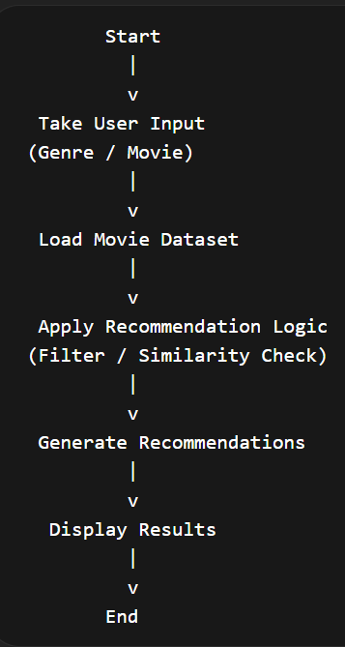

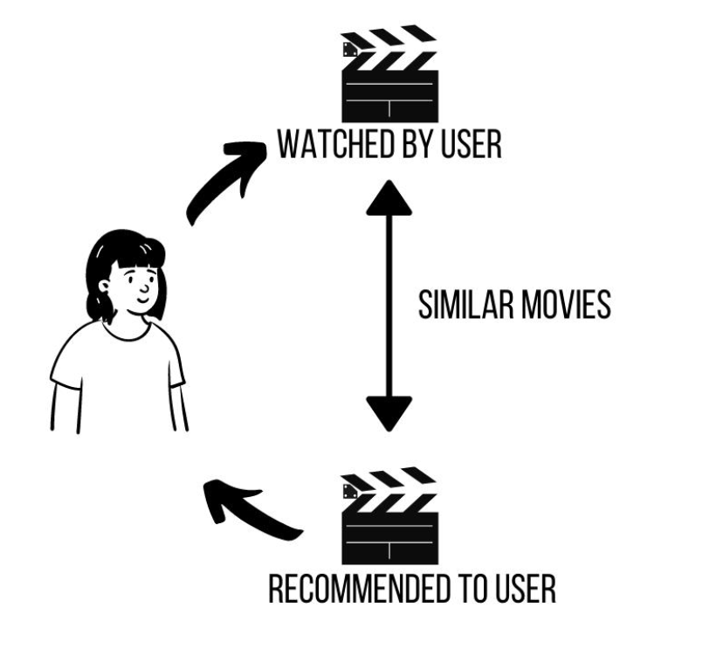

• Implementation Details :

1. Programming Language & Tools
- Language: Python
- Libraries Used:
  - Pandas: For loading, managing, and structuring the dataset.
  - Scikit-learn: For TfidfVectorizer (text processing) and cosine_similarity (calculating match percentages).
  - Difflib: For built-in typo forgiveness and string matching.
  - Questionary: For building beautiful, interactive terminal prompts.
2. Data Preprocessing Before making recommendations, the system cleans the data:
- Standardizes column names and strips whitespace.
- Replaces empty cells (NaN) with blank strings to prevent math errors.
- Combines Genre, Director, Cast, Language, and Year into a single, unified ai_context column.
3. Recommendation Technique A Content-Based Filtering approach using advanced NLP is used:
- Instead of simple word counts, TF-IDF Vectorization is used to weigh how unique and important certain words (like directors or niche genres) are across the whole dataset.
- Cosine Similarity calculates the angle between these vectors to determine how closely related two movies are on a scale of 0 to 1.

•Coding Part:
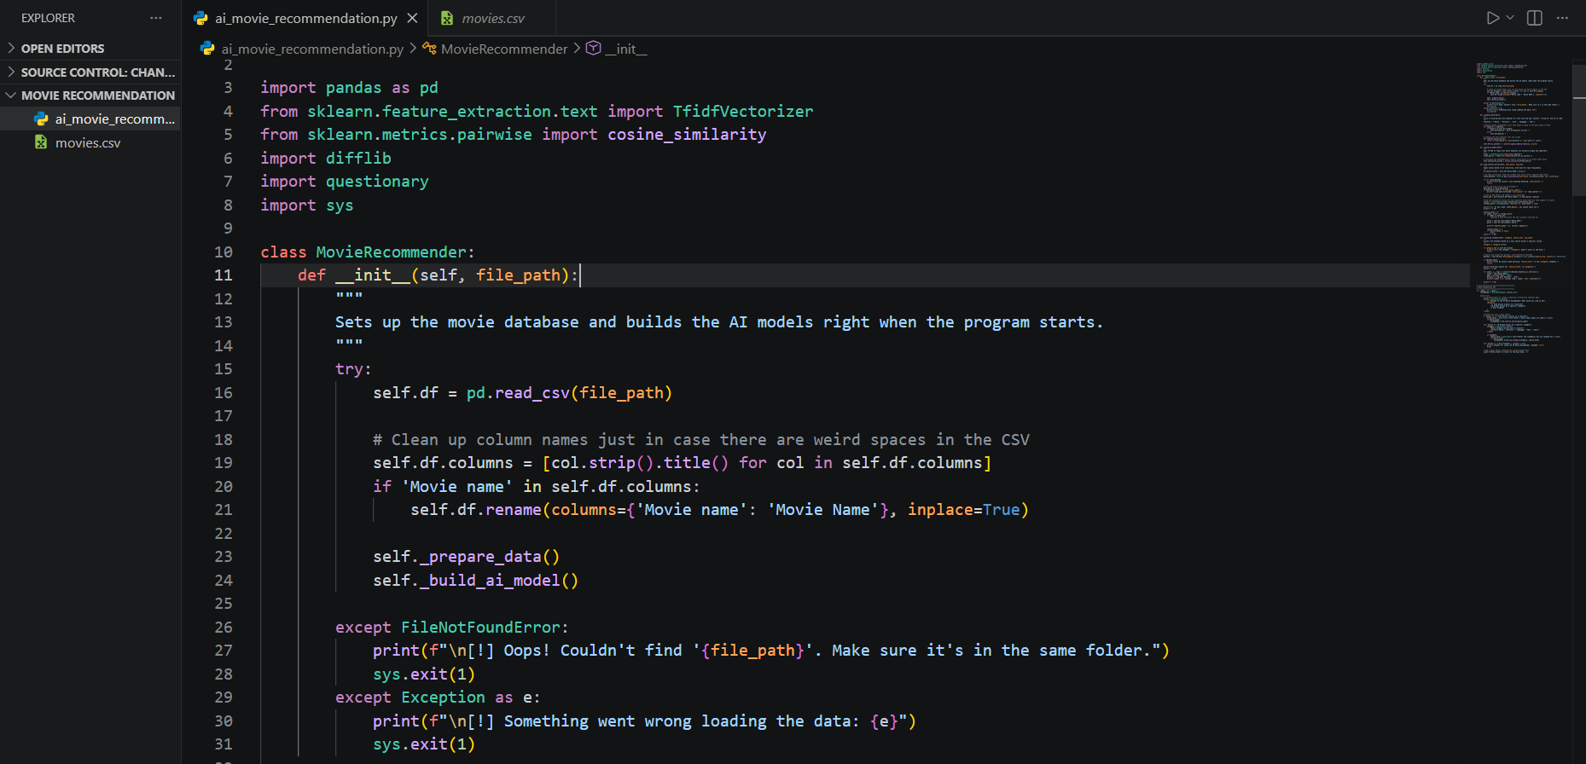

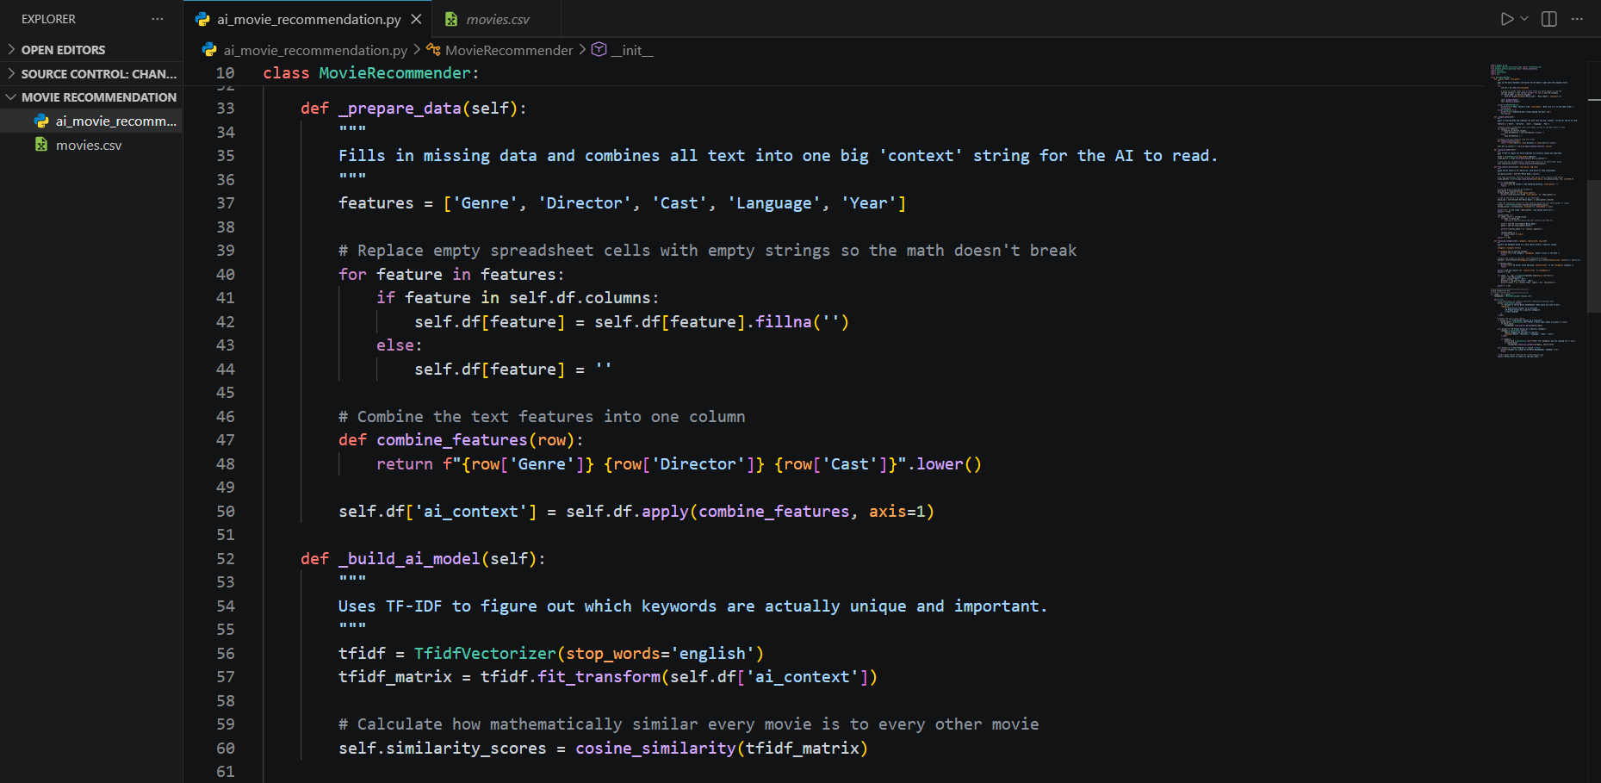

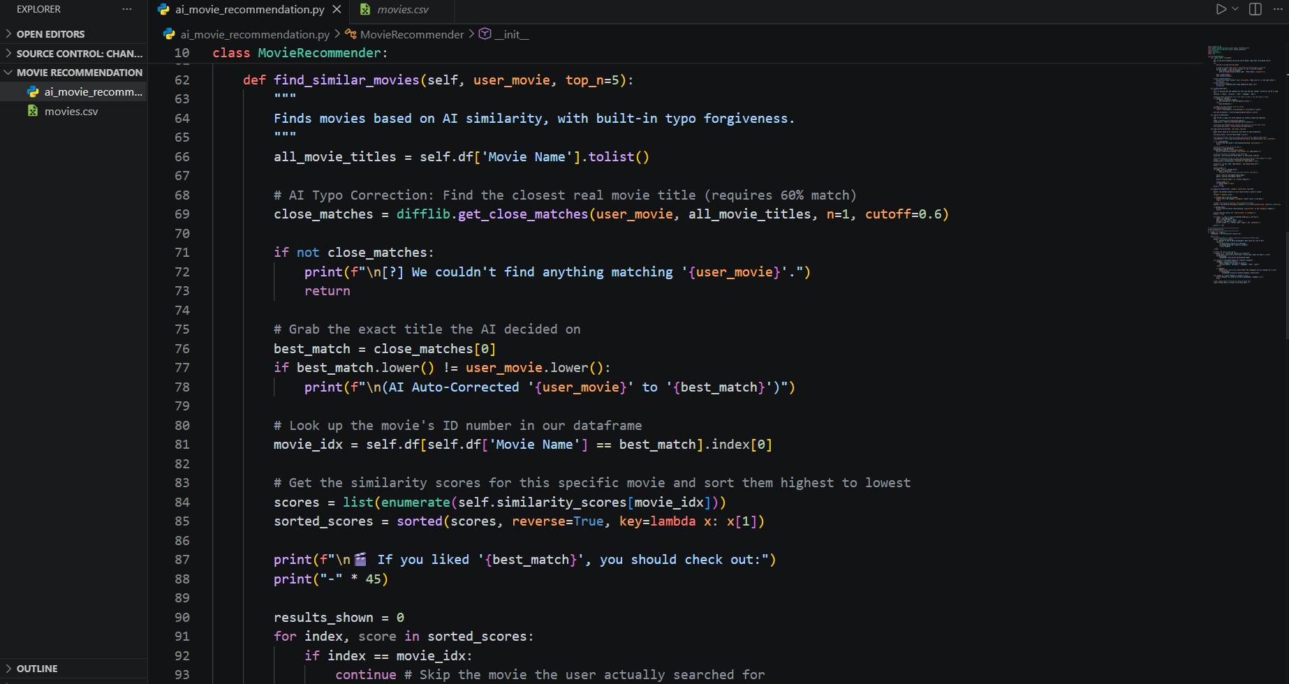

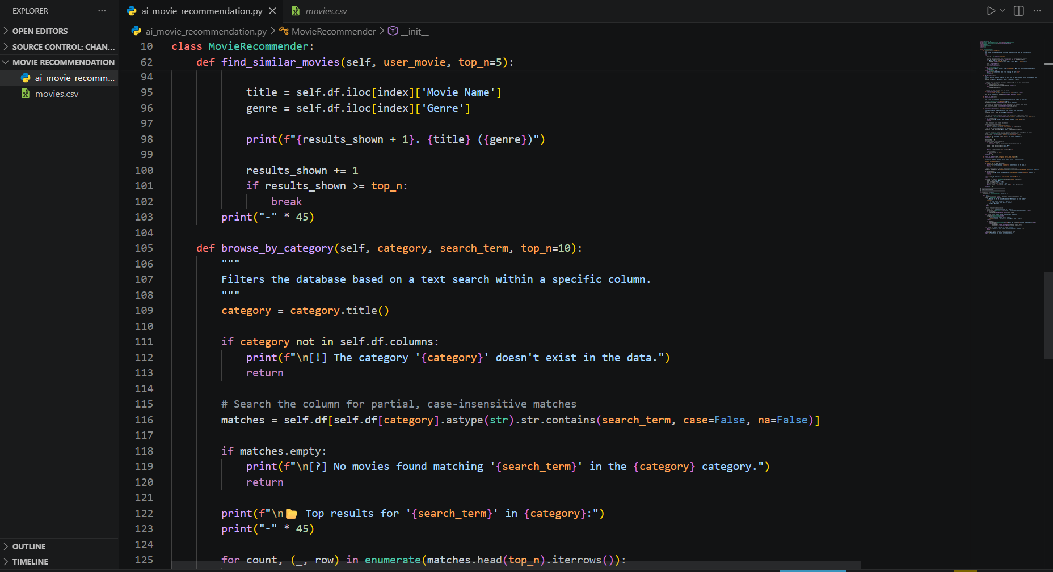

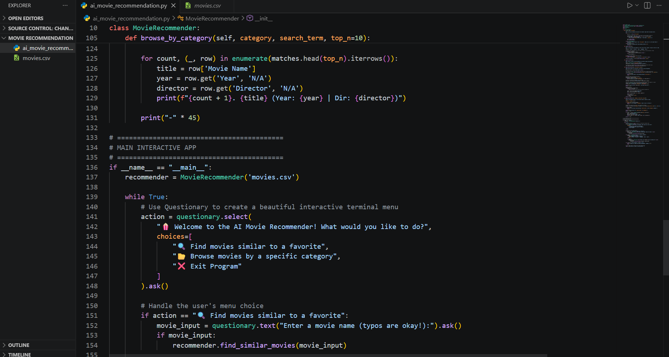

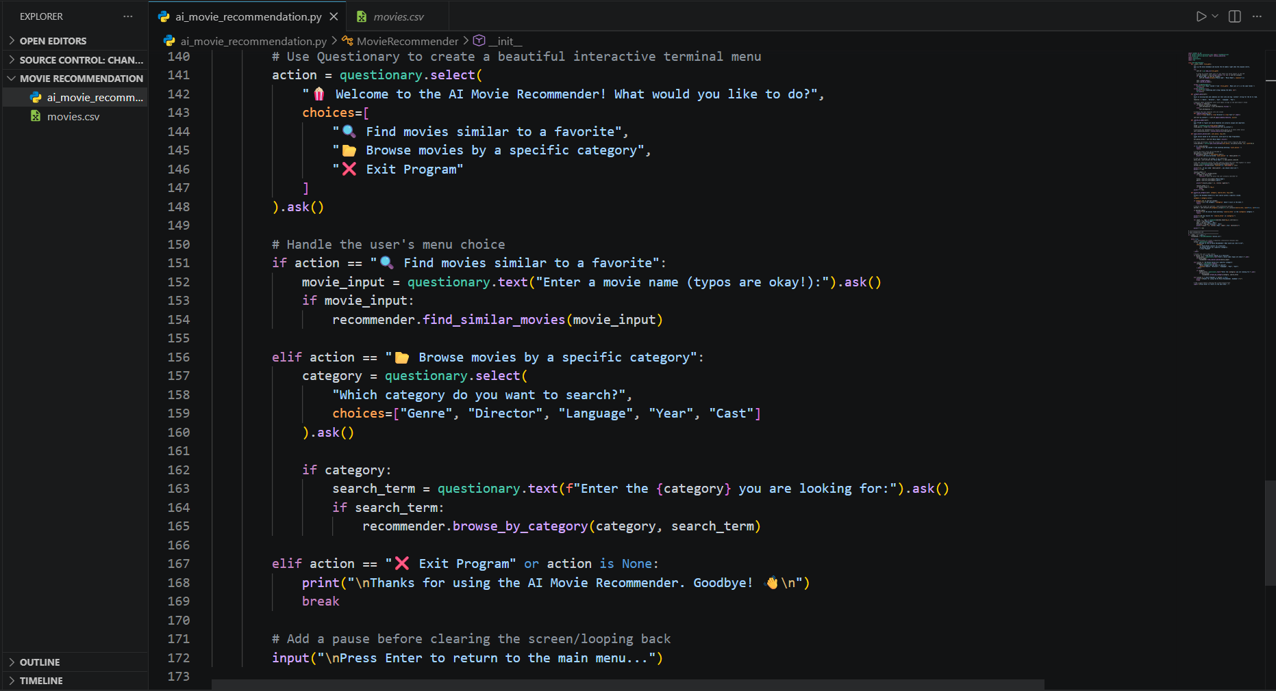

OUTPUT:-

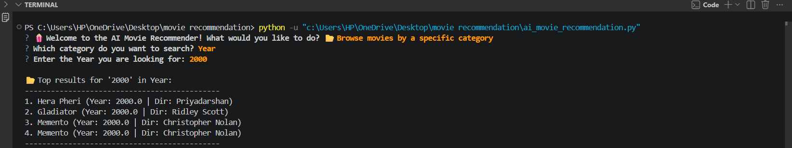

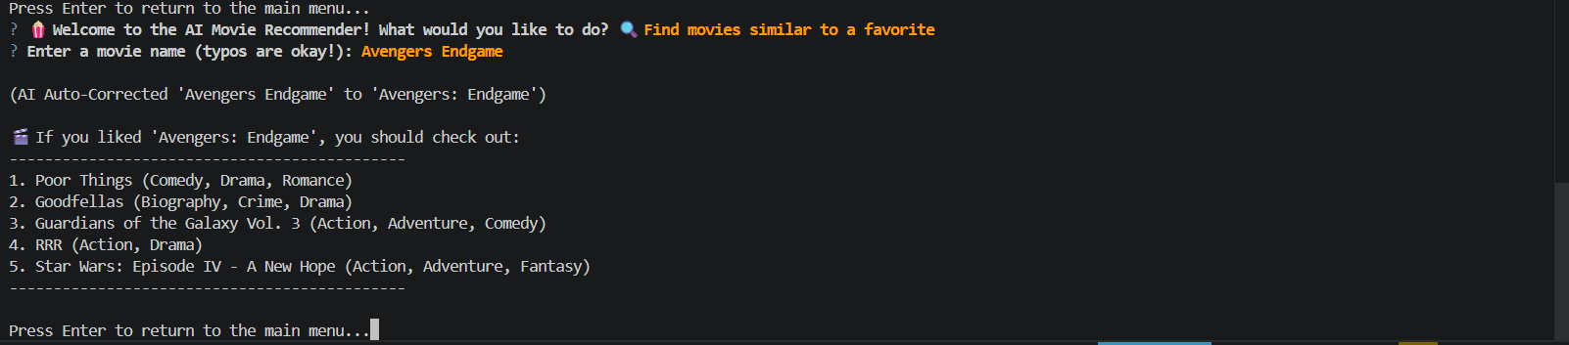

THANK YOU !!

